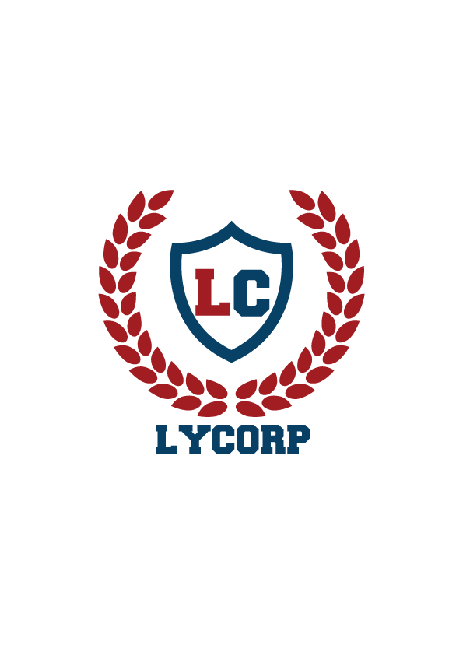

**Lyceum’s Entrepreneurs of Tomorrow**

**Brand Rush**

(Maximum Marks 10 for each category)

|  |  |  |  |  |  |  |
| --- | --- | --- | --- | --- | --- | --- |
| **Team name** | **Creativity/ Originality** | **Message Delivery:** Explicitly communicated product features | **Call to Action:** Is the consumer motivated to buy the product? | **Brand Awareness:**  Inspire trust, confidence and believability | **Total**  **(40)** | **Comments** |
| **MERAKI** |  |  |  |  |  |  |
| **BAY CORP** |  |  |  |  |  |  |
| **LOX N BOX** |  |  |  |  |  |  |
| **INNOVATORS** |  |  |  |  |  |  |
| **KEROSENE** |  |  |  |  |  |  |
| **3MNK** |  |  |  |  |  |  |
| **MARKETING MUESTROS** |  |  |  |  |  |  |
| **COORPERATE NAZIS** |  |  |  |  |  |  |
| **THE A TEAM** |  |  |  |  |  |  |
| **THE S-SQUAD** |  |  |  |  |  |  |
| **THE MARKETEERS** |  |  |  |  |  |  |
| **THE BLAZE** |  |  |  |  |  |  |
| **THRIAMUOS** |  |  |  |  |  |  |
| **LE CORPO TITANS** |  |  |  |  |  |  |
| **THE B-TEAM** |  |  |  |  |  |  |
| **ENIGMA** |  |  |  |  |  |  |
| **WHITE COLLAR CREW** |  |  |  |  |  |  |
| **THE TYCOONS** |  |  |  |  |  |  |
| **IMPRESSANIOS** |  |  |  |  |  |  |
| **XYZ** |  |  |  |  |  |  |